SmartPlant 3D Electrical
Student Workbook

Version 2007 | January 2007
Copyright
Copyright © 2007 Intergraph Corporation. All Rights Reserved.
Including software, file formats, and audiovisual displays; may be used pursuant to applicable software license agreement; contains confidential and proprietary information of Intergraph and/or third parties which is protected by copyright law, trade secret law, and international treaty, and may not be provided or otherwise made available without proper authorization.
Restricted Rights Legend
Use, duplication, or disclosure by the Government is subject to restrictions as set forth in subparagraph (c) of the Contractor Rights in Technical Data clause at DFARS 252.227-7013, subparagraph (b) of the Rights in Computer Software or Computer Software Documentation clause at DFARS 252.227-7014, subparagraphs (b)(1) and (2) of the License clause at DFARS 252.227-7015, or subparagraphs (c) (1) and (2) of Commercial Computer Software---Restricted Rights at 48 CFR 52.227-19, as applicable.
Unpublished---rights reserved under the copyright laws of the United States.
Intergraph Corporation
Huntsville, Alabama 35894-0001
Warranties and Liabilities
All warranties given by Intergraph Corporation about equipment or software are set forth in your purchase contract, and nothing stated in, or implied by, this document or its contents shall be considered or deemed a modification or amendment of such warranties. Intergraph believes the information in this publication is accurate as of its publication date.
The information and the software discussed in this document are subject to change without notice and are subject to applicable technical product descriptions. Intergraph Corporation is not responsible for any error that may appear in this document.
The software discussed in this document is furnished under a license and may be used or copied only in accordance with the terms of this license.
No responsibility is assumed by Intergraph for the use or reliability of software on equipment that is not supplied by Intergraph or its affiliated companies. THE USER OF THE SOFTWARE IS EXPECTED TO MAKE THE FINAL EVALUATION AS TO THE USEFULNESS OF THE SOFTWARE IN HIS OWN ENVIRONMENT.
Trademarks
Intergraph, the Intergraph logo, SmartSketch, FrameWorks, SmartPlant, INtools, MARIAN, and PDS are registered trademarks of Intergraph Corporation. Microsoft and Windows are registered trademarks of Microsoft Corporation. MicroStation is a registered trademark of Bentley Systems, Inc. ISOGEN is a registered trademark of Alias Limited. Other brands and product names are trademarks of their respective owners.

LAB-1: Routing Cableway-Pinpoint

Objective

After completing this lab, you will be able to:
- Rout Cableways with Control Tools
- Rout Cableways with SmartSketch

- Open a Session file with Imperial Units
Note: Session file stores settings from the last time you were in SmartPlant 3D. The name of the current session file appears in the title bar of the application, along with the name of the task, model and filter. One of the settings saved in the session file is the workspace. See the common labs on how to define a workspace
- Define Workspace to Display U04 and U04 CS
- If you are not in the Electrical task, then select Task -> Electrical
- Make sure permission group is set to Electrical
Note: Objects that you place directly in the model are assigned to the active permission group. Therefore, you are responsible of making sure the objects are assigned to the appropriate Permission Group

- Set Active Coordinate system to U04 CS
- Select set target to origin option
- Select Route Cableway command on the vertical toolbar
- Key in 5’ for E, 30’ for N and 26’ for EL and Left click in the view
- The system opens the Create Cableway Dialog box. Select “More…” option in the System property field to open the Select System dialog box. Select U04, Electrical, Control, CT system and Click OK
- On the Create Cableway dialog box. Select the cableway specification as follows:
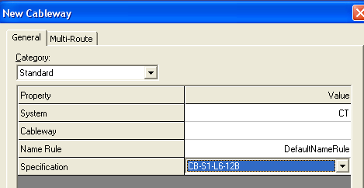
- witch the Category to Cable fill and set the following
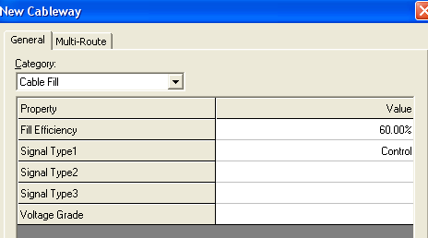
- Click OK to close the Create Cableway dialog
- Under Offset, select set offset reference
- Select Cardinal Point Option
- Select Bottom Center and OK on the form

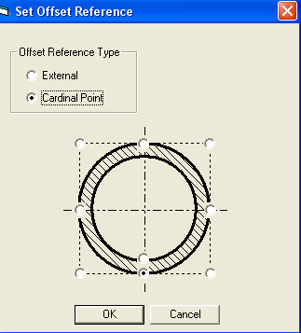

- Select Rectangle under Shapes and Key in 2’ for Width and 4” for the depth
- Go to the Route ribbon bar and key in 8’ in the length box.
- Go to the Route ribbon bar and set the working plane to PLAN.
- Position the cursor in the Easting direction.

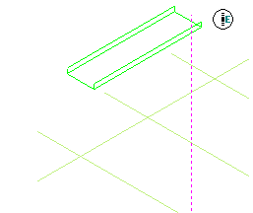

- Left mouse click to accept the endpoint.
- Go to the Route ribbon bar and key in 12’ in the length box.

- Position the cursor in the Northing direction.

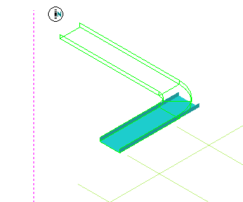

- Left mouse click to accept the next endpoint
- Go to the Route ribbon bar and key in 6’ in the length box.

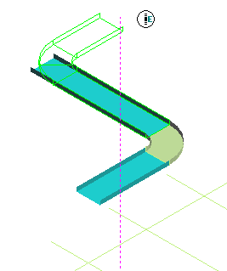

- Position the cursor in the Easting direction
- Left mouse click to accept the next endpoint
- Right mouse click to terminate the Route cableway command.
- Finished Run should resemble this

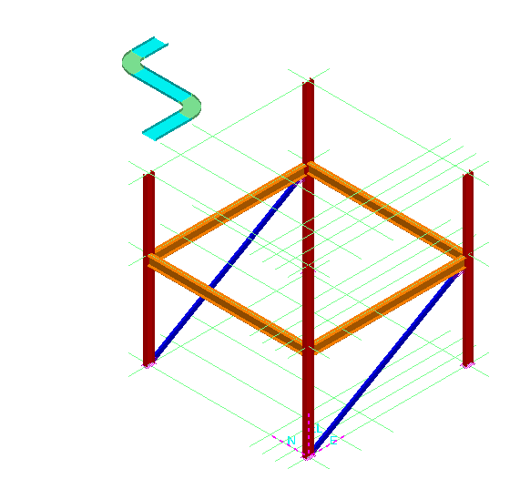

- Select Route Cableway command on the vertical toolbar
- Make sure Active CS is U04 CS
- Key in 30’ for E, 50’ for N and 26’ for EL as starting point
- Keep all the defaults on New Cableway Form (same as previous lab)
- Change the Width to 2’ and depth to 4”
- Route the shown Cabletray Run
10’ East 10’ Up 5’ East 5’ North
12’ East 10’ South 8’ 6” Down 5’ South

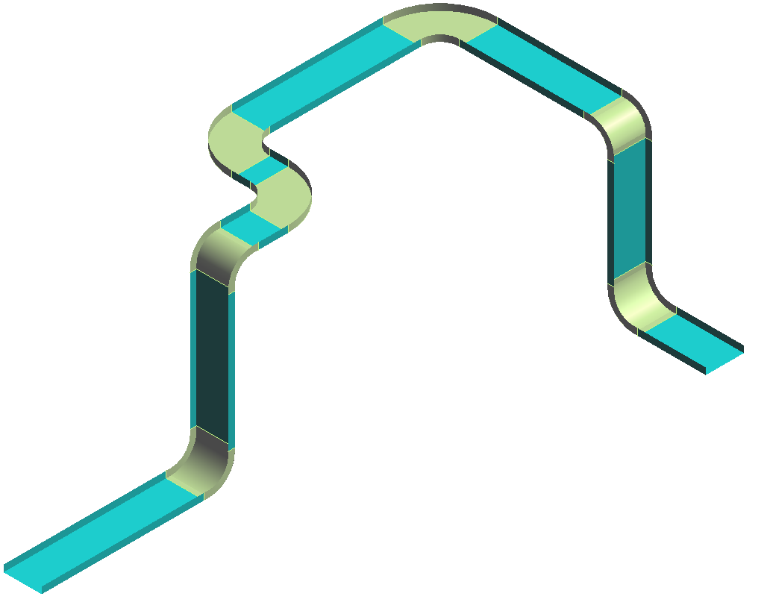

LAB-1A: Routing Cableway - SmartSketch

Objective

- Open a Session file with Imperial Units
- Define Workspace to Display U04 and U04 CS
- If you are not in the Electrical task, then select Task -> Electrical
- Set Active Coordinate system to U04 CS
- Select set target to origin option
- Re-Position Target to grid intersection shown below
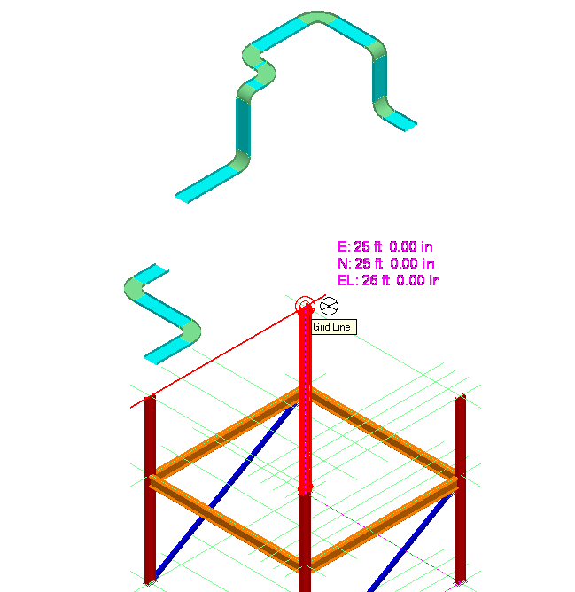
- Select Route Cableway command on the vertical toolbar
- Start new cableway, 3’ North of above intersection (Key in 0’ fro East, 3’ for North and 0’ for EL)
- Keep same defaults as previous lab on New cableway form
- Change the width to 1’ 6” and depth to 4”
- Route 10’ East and Go South until you are aligned with First E/W grid plane as shown. Left click to place the tray and right click to terminate the command
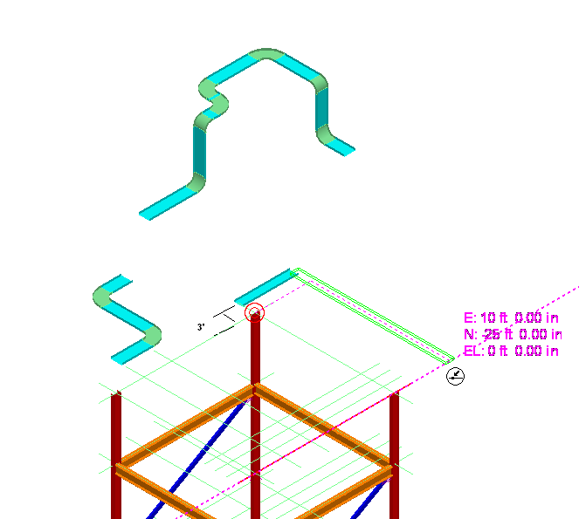
.

LAB-1B: Routing Cableway from End Features

- Open a Session file with Imperial Units
- Define Workspace to Display U04 and U04 CS
- If you are not in the Electrical task, then select Task -> Electrical
- Set Active Coordinate system to U04 CS
- Select set target to origin option
- Click Route Cableway command on the vertical toolbar.
- Select the N-E end of Tray placed in Part I

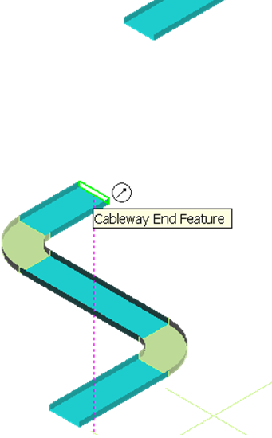

- Set the Route Plane to Plan.
- Move Cursor toward North and Middle Mouse Click to lock in N-S direction
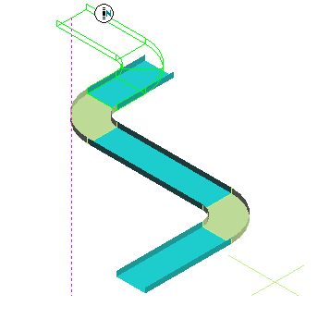

10 With N-S direction locked, move the cursor over West-East Run of second tray, until the intersecting lines show up. Left click to place the tray.

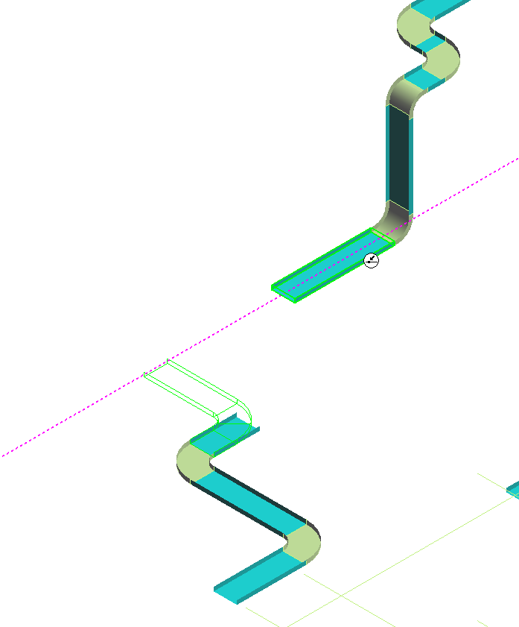

11 Right click to finish the run

LAB-1C: Connecting Cableways

- Open a Session file with Imperial Units
- Define Workspace to Display U04 and U04 CS
- If you are not in the Electrical task, then select Task -> Electrical
- Set Active Coordinate system to U04 CS
- Select set target to origin option
- Click Route Cableway command on the vertical toolbar.
- From Ribbon Bar Disable the offset (Disable the Cardinal Point routing).
- Select the N-E end of Tray placed in Part I
- Join the two trays by Starting From the West end of Second Tray and connecting to the North end of First tray.

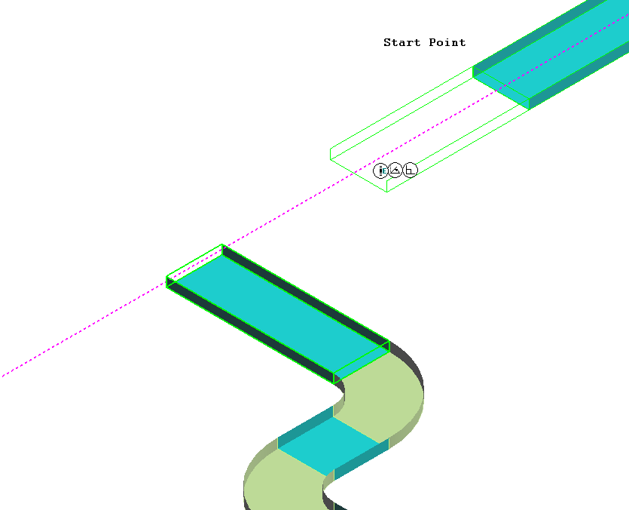

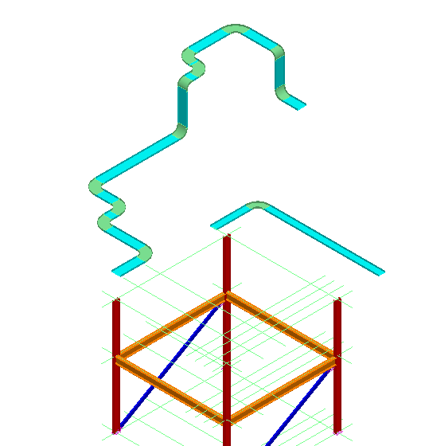

- Select Route Cableway command
- Start at the West end of 18” x 4” Tray as shown
- Connect to the East west Run tray as shown
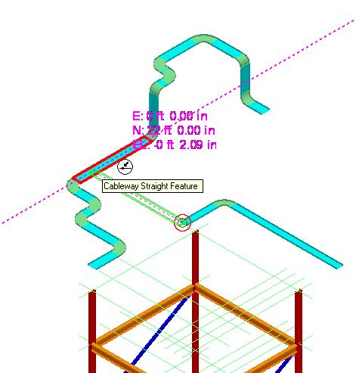

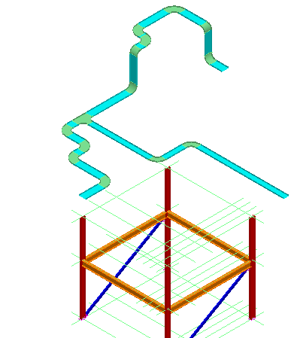

LAB-1D: Relative Tracking

- Open a Session file with Imperial Units
- Define Workspace to Display U04 and U04 CS
- If you are not in the Electrical task, then select Task -> Electrical
- Set Active Coordinate system to U04 CS
- Enable the relative tracking option.
- Click Route Cableway command on the vertical toolbar.
- Select the end feature at South end of the Tray (see figure) as starting point

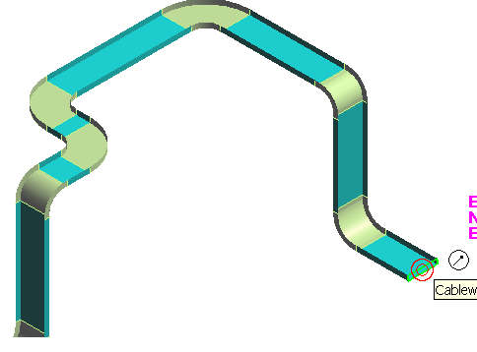
- Key in East 10’, North -10’ and El 0’
- System will show the new dynamics. Left click to place the run.
- Then place another run due East 15’ long.

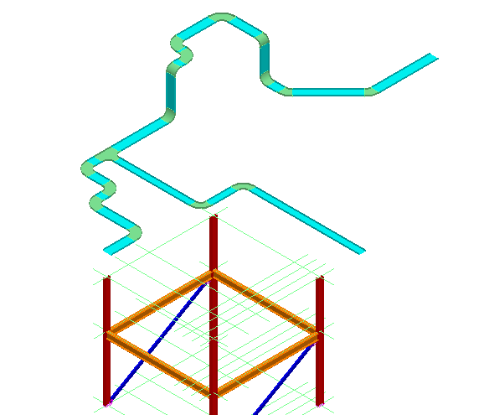

LAB-1E: Spherical Coordinates

- Open a Session file with Imperial Units
- Define Workspace to Display U04 and U04 CS
- If you are not in the Electrical task, then select Task -> Electrical
- Set the Pin Point readouts to spherical coordinate system.
- Re-position Target to East end of Tray routed in above lab
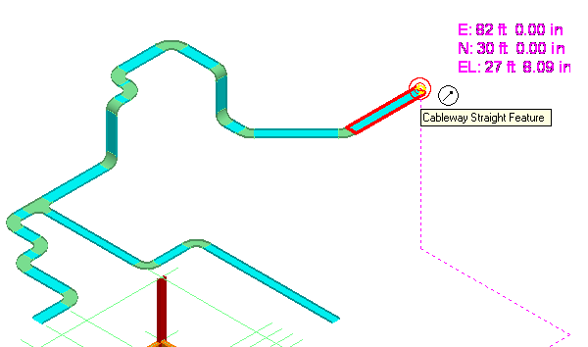
- Click Route Cableway command on the vertical toolbar.
- Select the East end of Tray placed in previous lab(shown above)
- Go to the Pin Point ribbon bar and lock the Distance, Horizontal and Vertical directions as follows:
Absolute Distance: 10’
Horizontal (N>CW): NE 45.00 Deg
Vertical(Plan>CCW): Flat with Plan 0.00
- System Shows the dynamics of new Tray at 45 degree from North
- Left click to place the tray
- Place another Tray East 5’

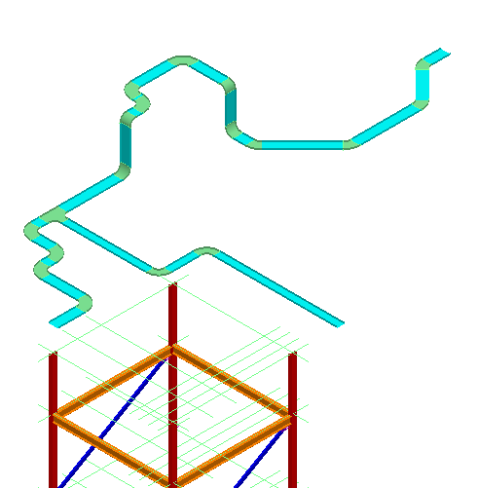

LAB-1F: Cableway – Size Change

- Open a Session file with Imperial Units
- Define Workspace to Display U04 and U04 CS
- Click Route Cableway command on the vertical toolbar
- Select the East most end of Tray
- Change the size to 18” X 4”
- Route East 5’.
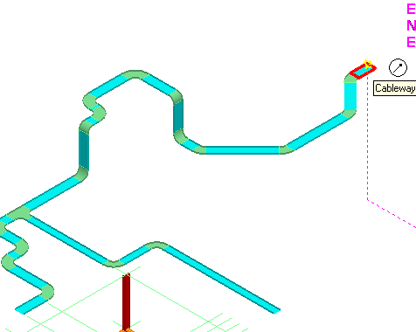

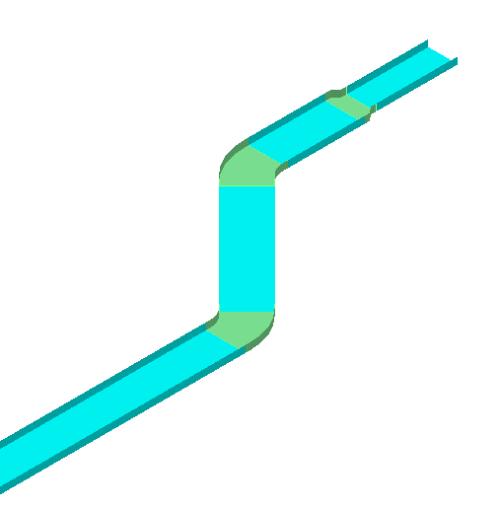

LAB-1G: Branching Out

- Open a Session file with Imperial Units
- Define Workspace to Display U04 and U04 CS
- Select Reposition Target (F12).
- Place target at the South End Feature as shown

``` 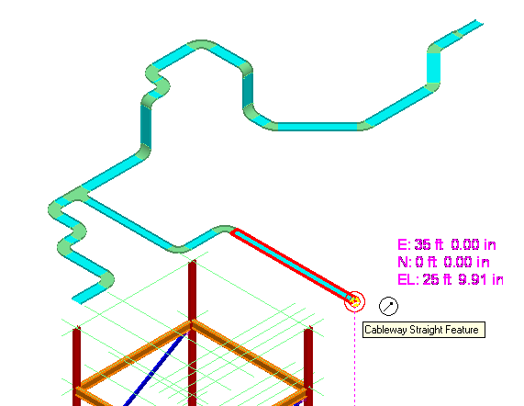

- Select Route Cableway command on the vertical toolbar
- Key in 10’ for North select the Straight Feature
- Route East 10’

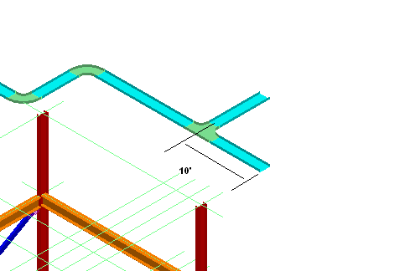

LAB-2: Insert Component

- Open a Session file with Imperial Units
- Define Workspace to Display U04 and U04 CS
- Select insert component command
- Select the end feature as shown

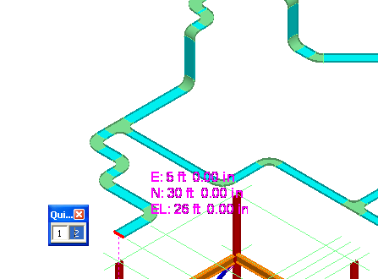

- Select more under part list
- Expand the Catalog Browser and Select Branches. Sort the components by Component type and find Cable Tray Parts\Cable Tray Tee\CT Horizontal Tee\Cable Tray Reducing Tee
- Select Horizontal Reducing Tee, from 2’ X 4” to 1’ X 6”, Bend Radius 2’. Part Number 4P-24-18HT12
Part Number: Once you understand how parts are numbered, selection becomes very easy. Lets explore part number 4P-24-18HT12, in this: 4P is Series, 24 the main size, 18 is reducing size, HT for Horizontal Tee and 12 is turning radius.
- Select the part and OK on the Catalog browser
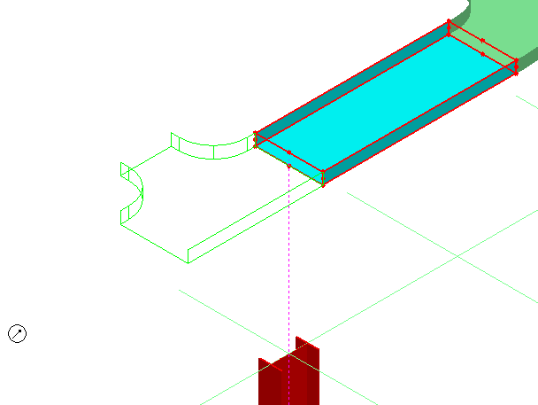

- Select Finish.
- Right click to cancel the command
- Click Insert Component on the vertical tool ribbon
- Select the end feature of tee as shown
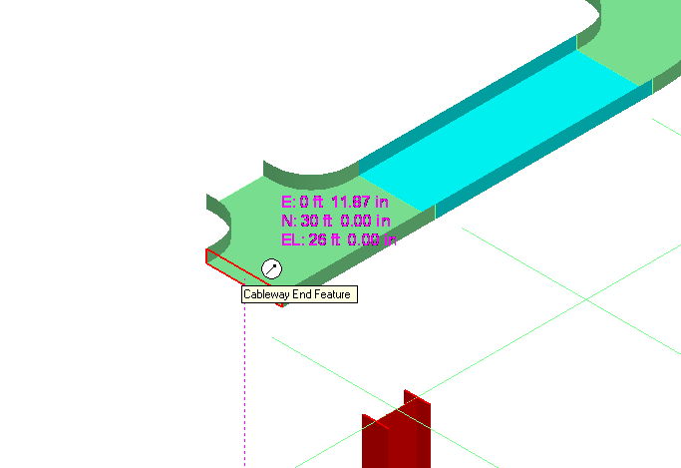

13 From Catalog select Bends, and then select 2’ X 4”, 45 degree Outside Vertical
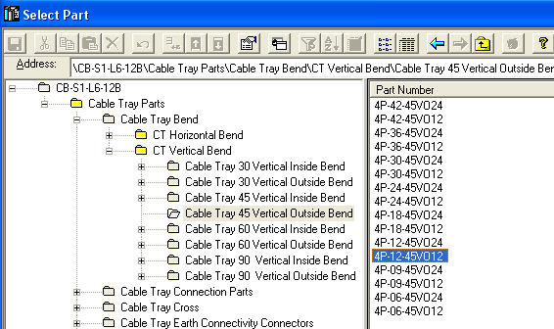

- Select Finish
- Place an other Inside vertical bend 45 as shown(45P-24-45VI12)

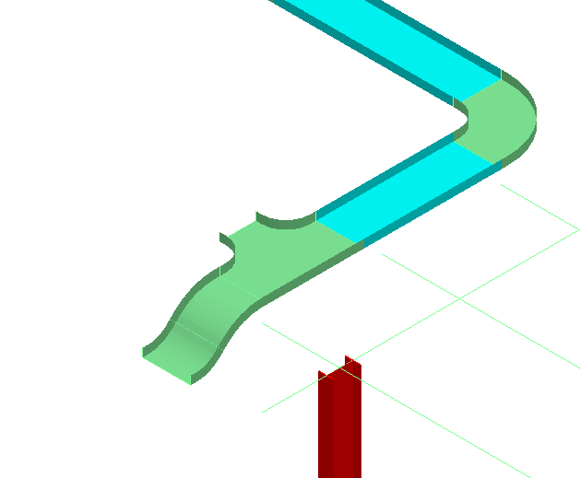

- Select Finish
- Place an other Inside vertical bend 45 as shown(45P-24-45VI12)
- Route West 5’ from the fitting as shown
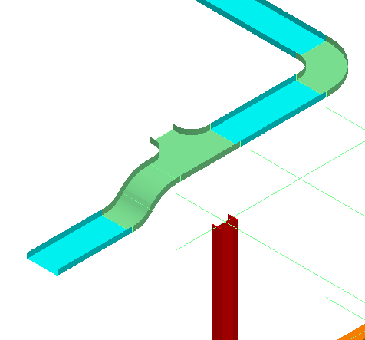

- Place a TEE, and route tray as shown in the picture below
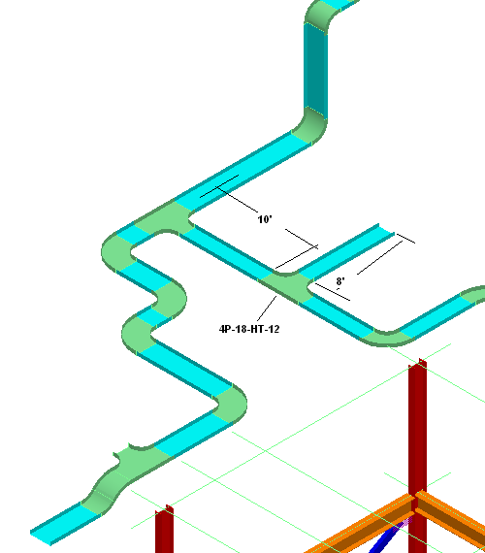

- Select Insert Component on the vertical tool ribbon.
- Activate Point Along command (1 in the picture below)
- Select Reference Option (2 in picture).
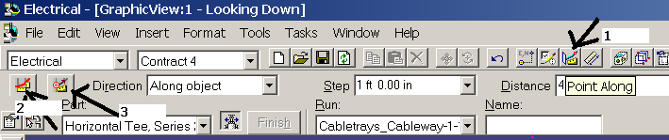
- Select the Straight feature as shown
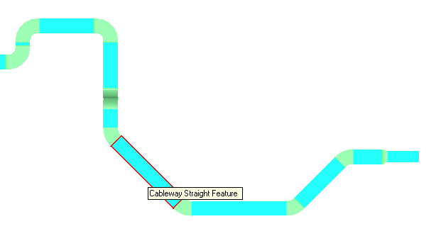
- Select Reference Point option (3 in picture).
- Select the End Feature at the top end
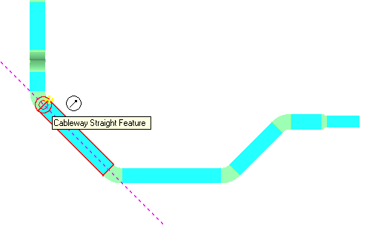
- Select insert component command
- Select same straight feature
- Select 24”, Horizontal Tee, Radius 12” from catalog
- Key in 5’ for distance
.
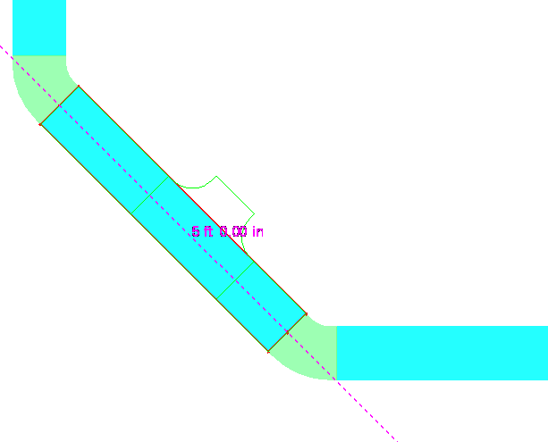

- Left click to accept the position
- Finish to place the TEE

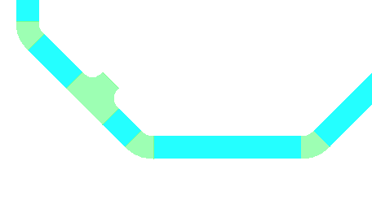

LAB-3: Cableway No Part Spec

- Open a Session file with Imperial Units
- Define Workspace to Display U04 and U04 CS
- Select Route Cableway command on the vertical toolbar
- Select New Cableway option under Run
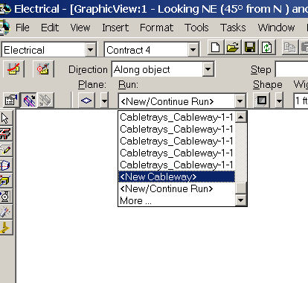

- On new Cableway form, change the Spec to Cws0 . Ok on the form
- Select the end feature as starting point. Change the Size to 2’ X 4”
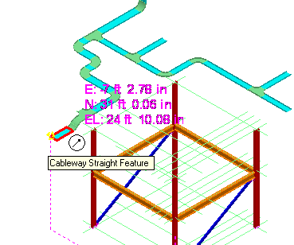
- Route West 5’
- Select insert transition command from Vertical tool bar. Select the west end of Cableway.
- Select 3’ for Width, 2’ for depth and 4’ for length.

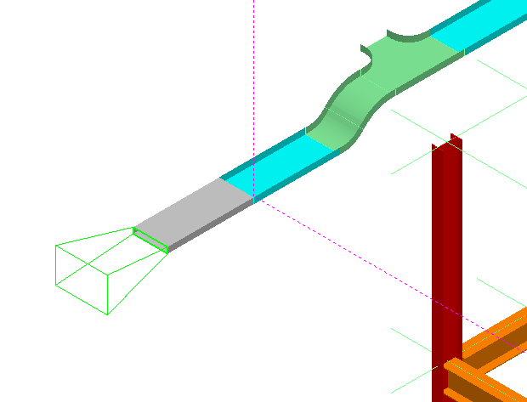

- Select finish.
- Select Route cableway and route from transition feature, 10’ west, 15’ South
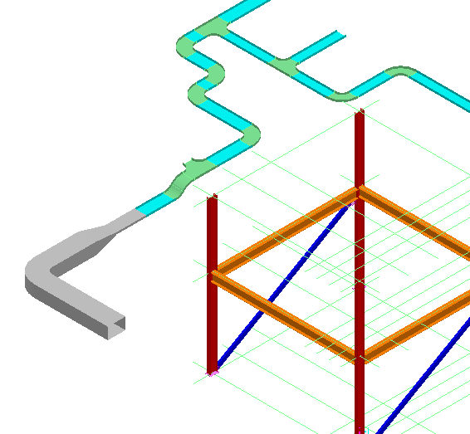

- Select insert transition command
- Select the South end of Cableway
- Change the Width to 18” and Depth to 1’
- Change the length to 2’
- Select Align Bottom left option under Align (first row last button)
- Select Finish
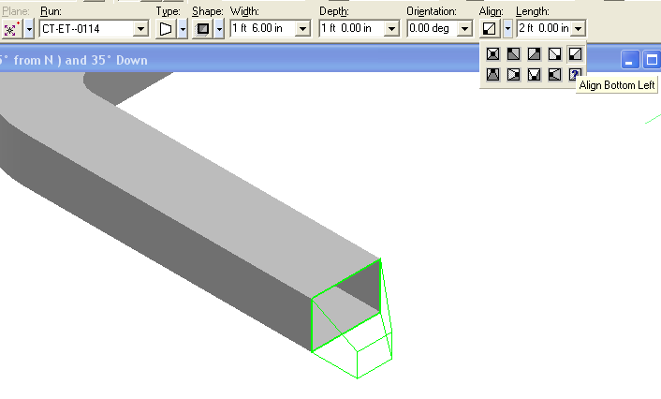

18 Route 10’, South from the transition

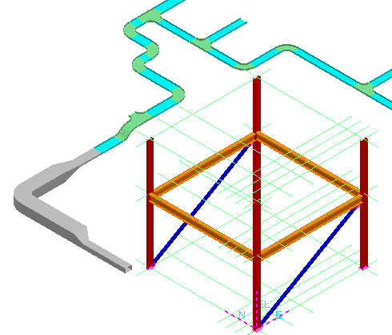

LAB-4: Cableway Editing

- Open a Session file with Imperial Units
- Define Workspace to Display U04 and U04 CS
- Activate Pin Point Ribbon Bar
- Change the locate filter to Cableway Feature
- Activate Relative Tracking
- Select the Straight Feature Shown below
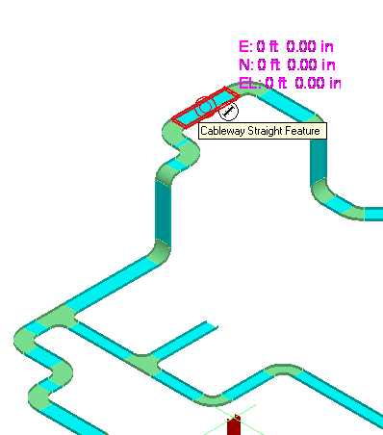
- Select Move To option
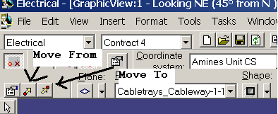
- Key in 5’ North
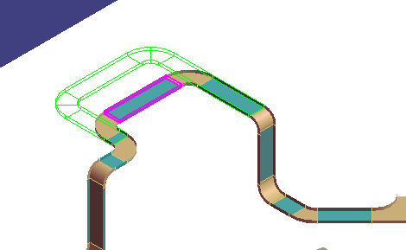

- Left click to Accept the move. Right click to cancel the command
- Select Point Along option
- Define the SF shown as Reference object
- Define the point shown as Reference point
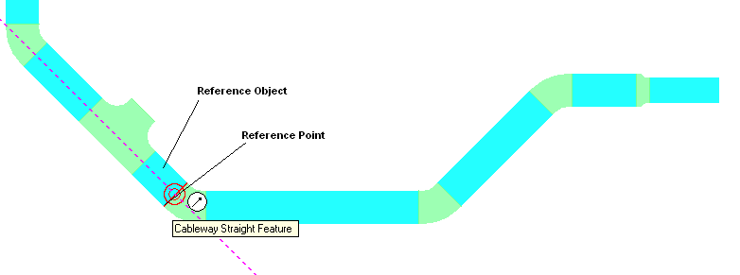
- Select the Straight Feature at the end, while holding shift key select the Turn Feature as shown
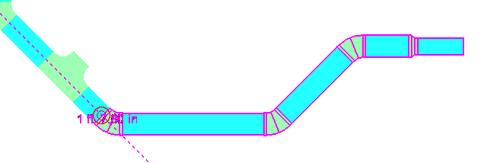

- Select the Common Move command
- Check the fast move option
- Select top End Feature of Elbow as From point
- Key in 5’ for distance
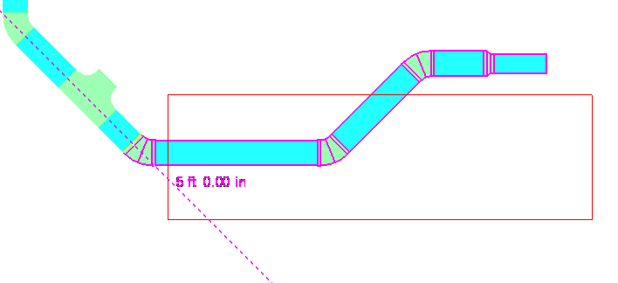
- Left click to Accept new location

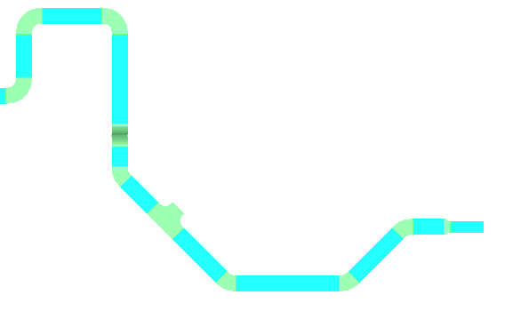

- Move the Tee Next to Elbow as shown below
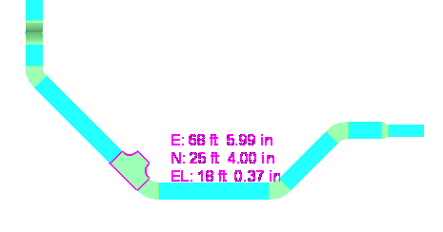
- Using move command, move the Elbow so it changes to 90 degree, and 45 degree elbow next to Tee disappears
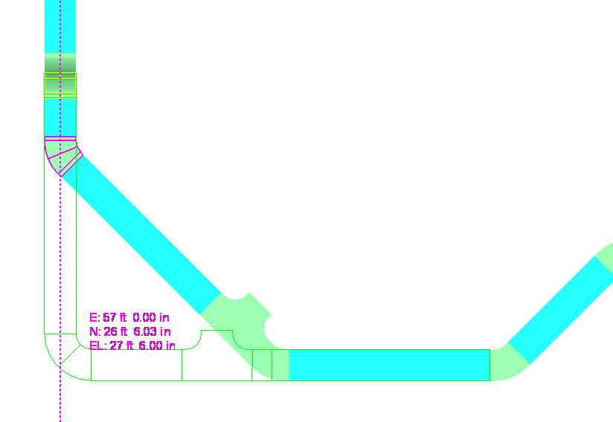
- This can be done by changing the fitting angle to 90 degree, and locking the other 90 angle in the ribbon bar

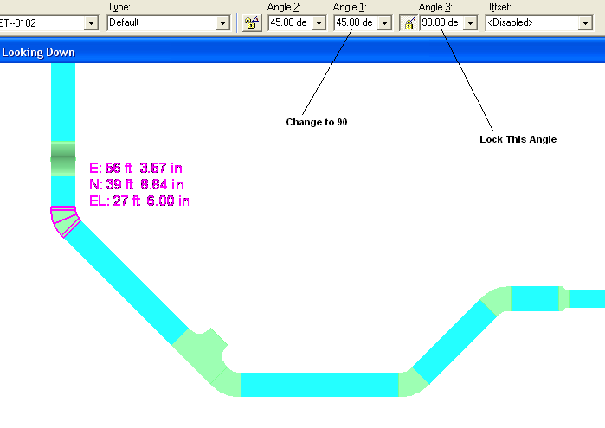

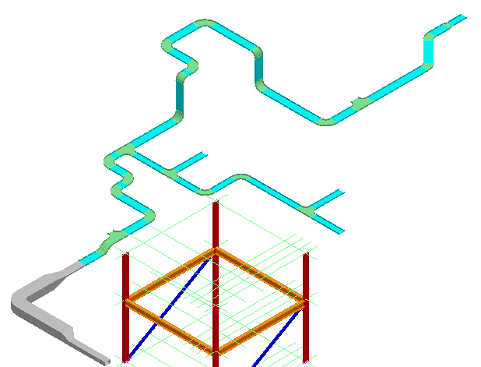

LAB-5: Setting Default Properties

- Open a Session file with Imperial Units
- Define Workspace to Display U03 and U03 CS
- Activate Pin Point Ribbon Bar
- Change the locate filter to All
- Expand Workspace explorer and select CT under, A2 > U03>Electrical>Control
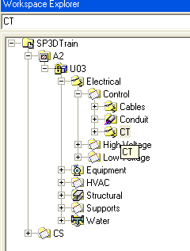
- Open properties page for This system (right click > properties)
- From System Properties options, Switch to Default Properties Value Tab
- Under Standard category, Select Specification to CB-S1-L6-12B
- Change the Category to Cable Fill
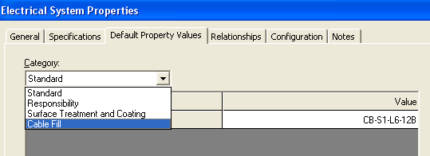

- Define following Values
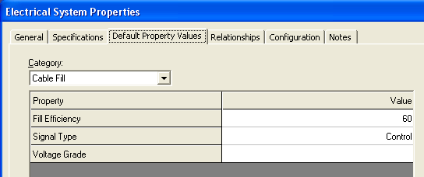

Note: If you want to use cable Auto route functionality, you must define these 2 attributes
- OK on the form
- Expand Workspace explorer and select CT under, A2 >U03>Electrical>Low Voltage
- Open properties page for This system (right click > properties)
- From System Properties options, Switch to Default Properties Value Tab
- Under Standard category, Select Specification to CB-S1-L6-12B
- Change the Category to Cable Fill
- Define fill Efficiency at 60%, and Signal type to Power
- OK on the form
- Save session file

LAB-6: Multi Tray Routing

- Open a Session file with Imperial Units
- Define Workspace to Display U03 and U03 CS
- Activate Pin Point Ribbon Bar
- Change Active CS to U03 CS
- Set target to origin option
- Select Place Equipment command from the vertical toolbar to open the select Equipment Dialog box.
- Locate the electrical enclosures part number BA-106E42309-1E using the tree view. Expand the Equipment Folder and the Electrical Enclosure Folder until you see the part. Select the part and click the OK button.
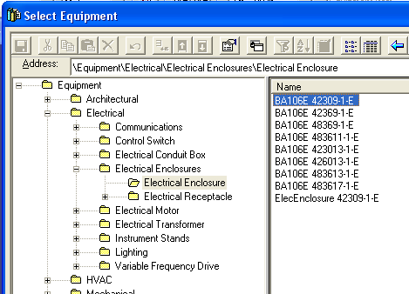
- Name the equipment, E-100A
- Change the System to A2>U03-> Equipment System
- Switch to Position and orientation category, and make following changes:
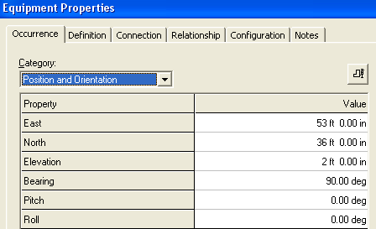
- Select place equipment command
- Select same part as above
- Name the equipment, E-100B
- Change the System to A2>U03-> Equipment System
- Switch to Position and orientation category, and make following changes:
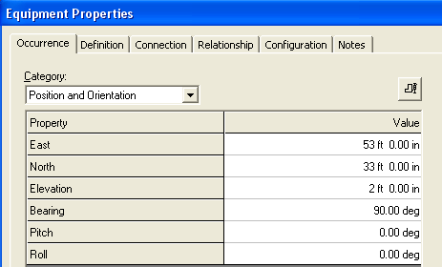

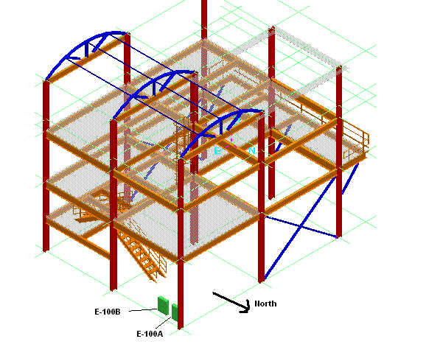

- Select Route Cableway command
- For Starting location, Key in East 53’ 2”, North 37’ 2” and EL 6’
- Click in the view
- On the New cableway select A2, U03, Electrical, Control, CT for system
Note: If you get a warning about systems, select the new system to inherit properties from parent system
- Software should update the Spec info based upon the default Parent system settings
- Switch to Cable fill category, verify the information is correct
- Switch to Multi Route Tab
- Make following changes
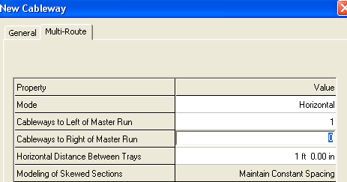
- Ok on the form
- Select 2’ for Width and 4” for depth
- Route the shown cabletrays. Refer to pictures for details
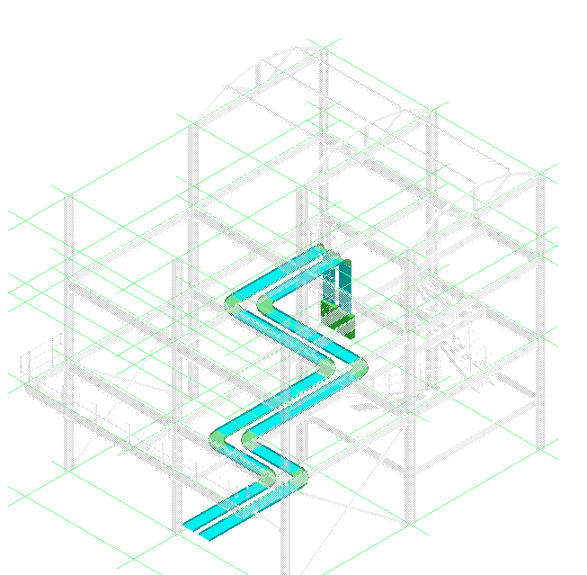

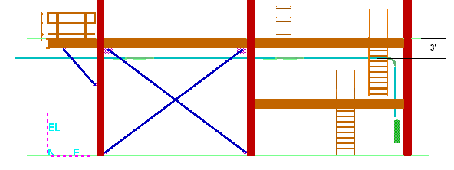

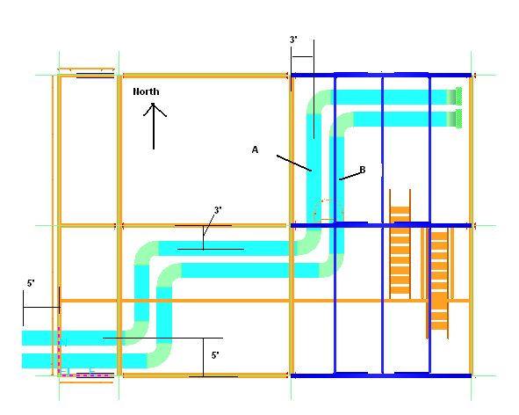

- Set locate filter to Cableway
- Select the Cableway Marked B, in above picture
- Open its property page, Change the system to A2, U03, Electrical, Low Voltage, CT and Switch to Cable Fill category. Change the signal type to Power

LAB-7: Stacked Tray Routing

- Open a Session file with Imperial Units
- Define Workspace to Display U02 and U02 CS
- Activate Pin Point Ribbon Bar
- Change Active CS to U02 CS
- Set target to origin option
- Set locate filter to All
- Select CT system, under A2, U02, Electrical, Control
- Set the default Spec to CB-S1-L6-12B
- Set Cable fill to 60% and Signal Type to Control
- Select CT system, under A2, U02, Electrical, Low Voltage
- Set the default Spec to CB-S1-L6-12B
- Set Cable fill to 60% and Signal Type to Power
- Select Route Cableway command
- For Starting location, Key in East 43’, North 1’ 8”, and EL 15’ 6”
- Click in the view
- On the New cableway select A2, U02, Electrical, Control, CT for system
Note: If you get a warning about systems, select the new system to inherit properties from parent system
- Software should update the Spec info based upon the default Parent system settings
- Switch to Cable fill category, verify the information is correct
- Switch to Multi Route Tab
- Make following changes
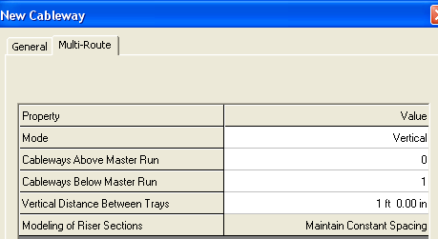
- Change the size to 24” X 4”
- Route the Tray as shown
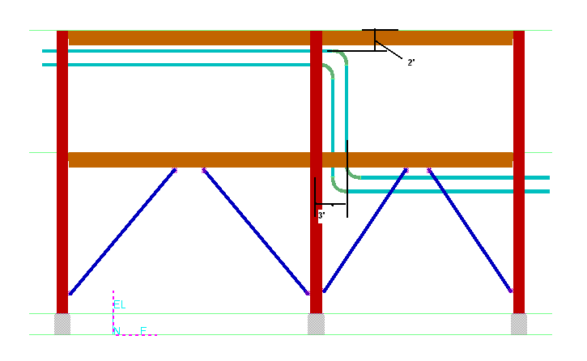
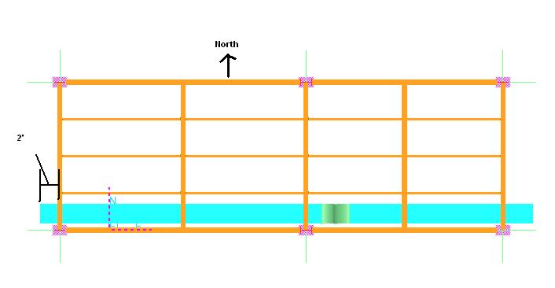

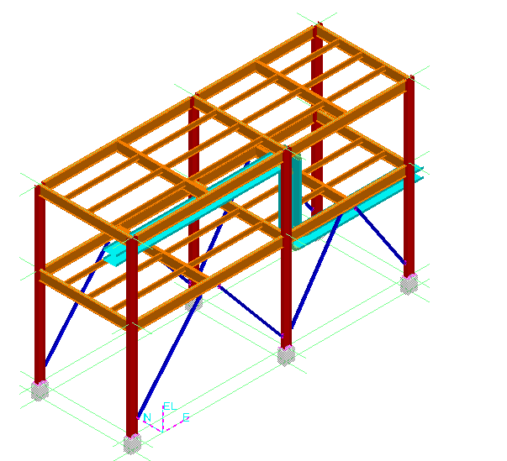

- Set locate filter to Cableway
- Select the Bottom cableway
- Open its property page, Change the system to A2, U02, Electrical, Low Voltage, CT. Switch to Cable Fill category. Change the signal type to Power

LAB-8: Stacked Tray Advance Routing

- Open a Session file with Imperial Units
- Define Workspace to Display U03 and U03 CS
- Activate Pin Point Ribbon Bar
- Change Active CS to U03 CS
- Set target to origin option
- Set locate filter to All
- Select Route Cableway command
- Key in East -5’, North 1’ 11”, EL 29’
- Click in the view
- On the New cableway select A2, U03, Electrical, Control, CT for system
Note: If you get a warning about systems, select the new system to inherit properties from parent system
- Software should update the Spec info based upon the default Parent system settings
- Switch to Cable fill category, verify the information is correct
- Switch to Multi Route Tab
- Make following changes
- Change the size to 30” X 4”
- Route the Tray as shown
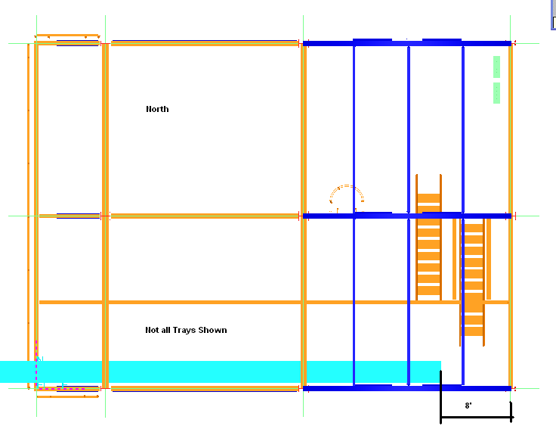
- Set locate filter to Cableway
- Select the Bottom cableway
- Open its property page, Change the system to A2, U03, Electrical, Low Voltage, CT. Switch to Cable Fill category. Change the signal type to Power
- Hide the Bottom(LV) Cableway
- Finish the Control CT as shown in the Picture
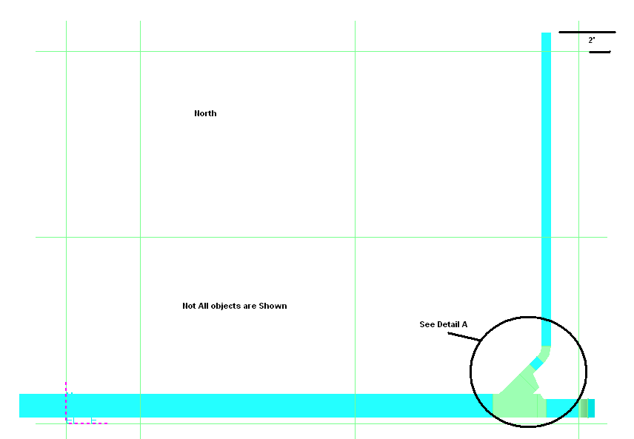

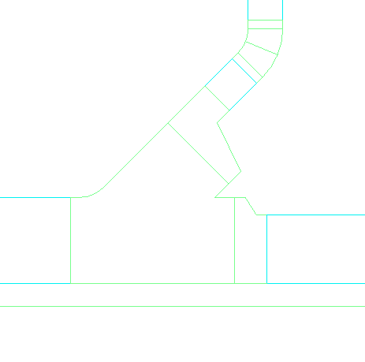
1
2
3
4
Detail A
- Horizontal WYE Left (30” X 4”) – Placed By origin
- Right Reducer (30” x 4” to 24” X 4”)
- Left Reducer( 30”X4” to 12”C4”
- Straight Tray 3’ Length
- Route Straight from 24” Reducer (2 in detail A), to East 55
- Place a 30 degree Outside Vertical Bend as shown
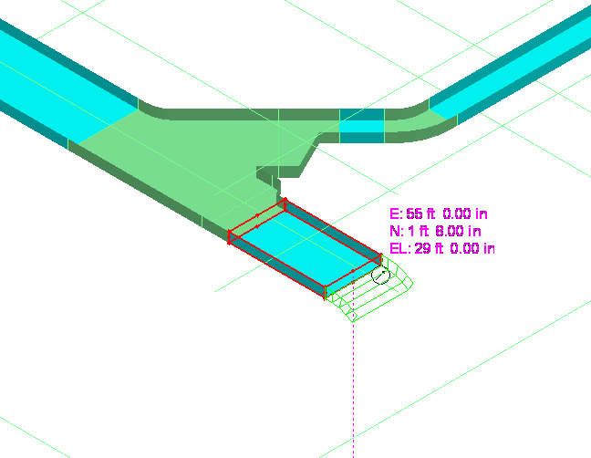
- Set your workspace to display U03 and U02
- Set your locate filter to Cableway Features
- Select the End Feature of Top Tray(control) in U02, and move it back few inches
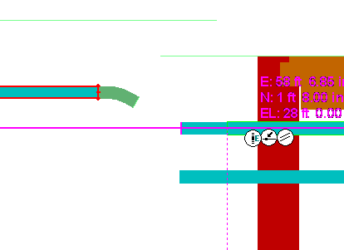
- Start routing from the 30 degree bend, and route to same elevation as the top tray in U02
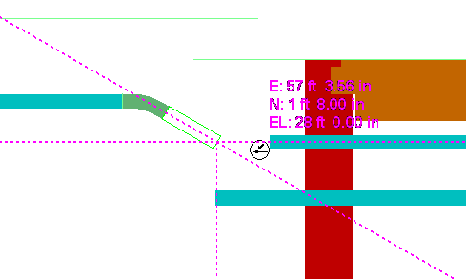
- Start routing at the end of U02 and connect the 2 trays as shown
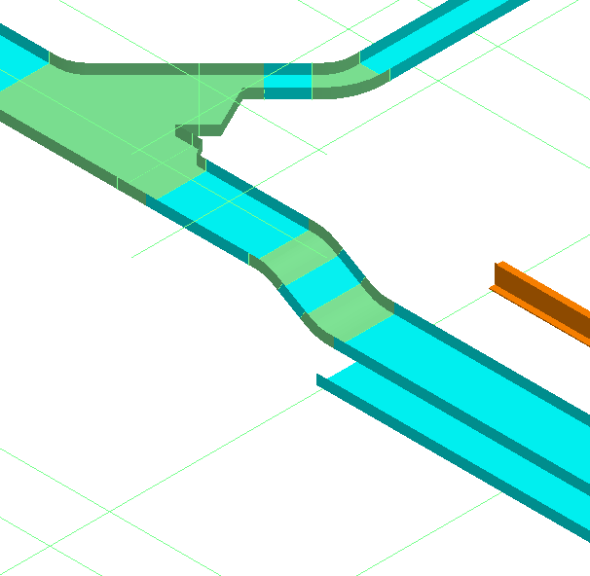

LAB-9: Stacked Tray Advance Routing (Optional)

- Open a Session file with Imperial Units
- Define Workspace to Display U03 and U03 CS
- Activate Pin Point Ribbon Bar
- Change Active CS to U03 CS
- Set target to origin option
- Set locate filter Cableway
- Hide all Cableways accept the Low Voltage on Elevation 27’ 7” as shown
- Select Route Cableway command
- Route as shown in the pictures
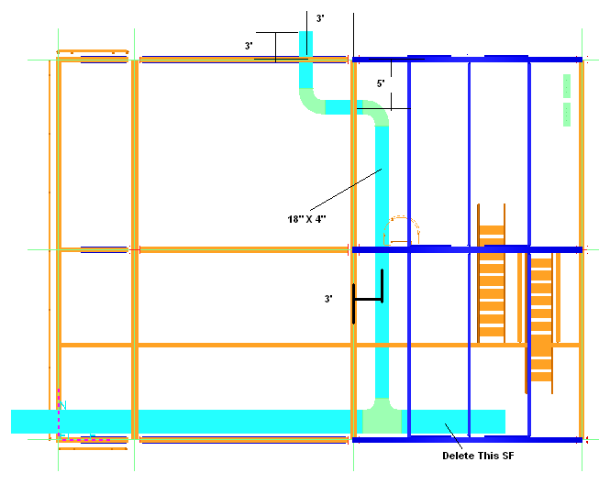
- Set locate filter to Cableway Feature and delete the SF shown marked in above pictures
- Place a 30” X4” to 24” X 4” Right Reduce after TEE
- Connect to the East end of Reducer and continue Routing to East 55’(U03 CS)
- Then using same method as previous lab, place a 30 degree outside bend, connect to the Low Voltage tray in U02 as shown

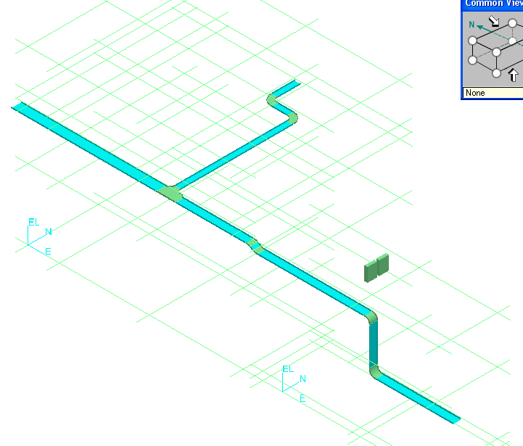

LAB-10: Connecting Cableways (Optional)

- Open a Session file with Imperial Units
- Define Workspace to Display U01 & U02
- Set locate filter Cableway
- Verify that Top Cableway n U01 is Control and Bottom is Low Voltage (if not, switch the systems)
- Connect the Trays from U02 to U01 any way
- Below Picture is just for reference
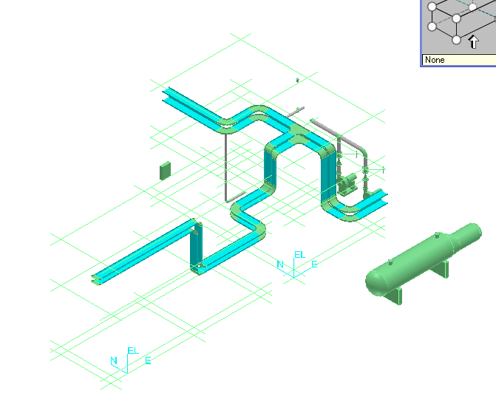

LAB-11: Electrical Equipment Placement

- Open a Session file with Imperial Units
- Define Workspace to Display U03 and U03 CS
- Activate Pinpoint
- Set Active CS to U03 CS
- Select set target to origin option
- Select place equipment command
- Browse to Equipment\Electrical\Lighting\Electrical Light and select ElectricalLight01-E

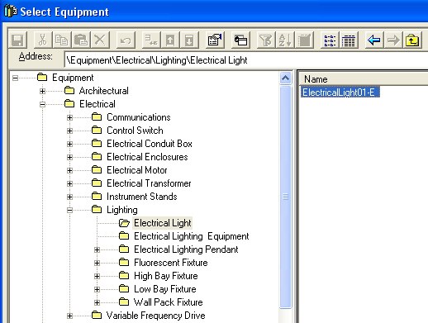

- On properties page, Change the Name to EL-U03-1
- Change the system to A2 > U03 > Equipment
- Switch to Equipment Dimension category
- Change the Equipment Height to 15’
- Switch to Position and Orientation category, and key East 31’, North -1’ EL 0 and change the Bearing to 180
- OK on the form
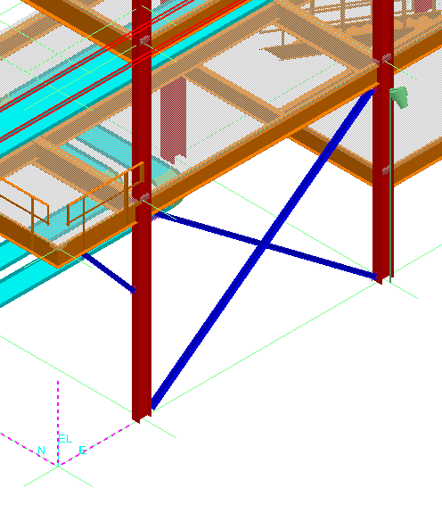
- Select place equipment command
- Select same light
- Name the light EL-U03-2
- Change the system to A2 > U03 > Equipment
- Switch to Equipment Dimension category
- Change the Equipment Height to 15’
- Switch to Position and Orientation category, and key East 55’, North -1’ EL 0 and change the Bearing to 180
- OK on the form
- Select place equipment command
- Select same light
- Name the light EL-U03-3
- Change the system to A2 > U03 > Equipment
- Switch to Equipment Dimension category
- Change the Equipment Height to 15’
- Switch to Position and Orientation category, and key East 8’, North -1’ EL 0 and change the Bearing to 180
- OK on the form
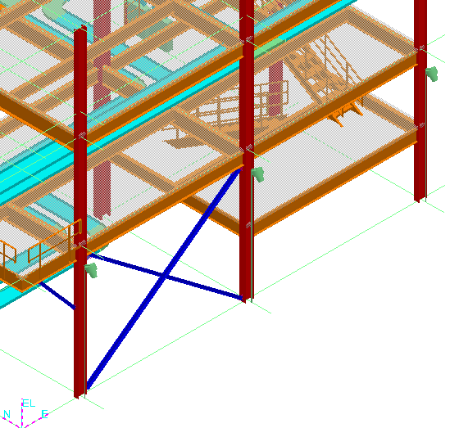

LAB-12: Electrical Equipment Placement with Relationship

- Open a Session file with Imperial Units
- Define Workspace to Display U03 and U03 CS
- Activate Pinpoint
- Select re-position target command
- Set the target at Grid intersection E 8, N 0, EL 44 in U03 CS
- Select place equipment command
- Browse to Equipment\Electrical\Lighting\Electrical Lighting Equipment and select Electricalequip01-E

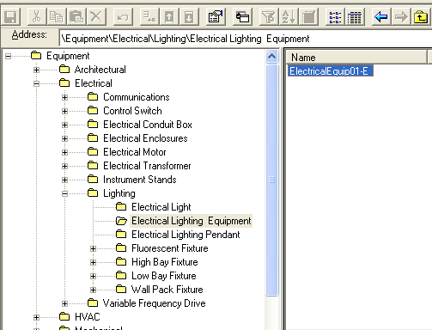

- On properties page, Change the Name to EL-U03-4
- Change the system to A2 > U03 > Equipment
- Ok on the form
- Switch to Equipment Dimension category
- Change the Equipment Height to 15’
- Key in 0 for North and –3 for EL. Select Connect under Relationship options. Select the Outside Surface of column on East side (as shown)
- Select Rotate Equipment Command.
- Select X axis (E/W axis) as Rotation axis. Type 45 for Rotation angle

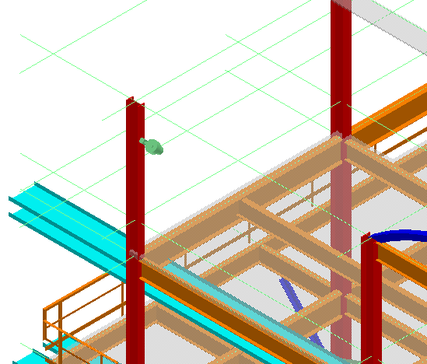

LAB-13: Conduit Routing

- Open a Session file with Imperial Units
- Define Workspace to Display U03 and U03 CS
- Activate Pinpoint
- Change active CS to U03 CS
- Select set target to origin command
- Select Place Equipment command from the vertical toolbar to open the select Equipment Dialog box.
- Locate the electrical enclosures part number BA-106E42309-1E using the tree view. Expand the Equipment Folder and the Electrical Enclosure Folder until you see the part. Select the part and click the OK button.
- Name the equipment, E-300A
- Change the System to A2>U03-> Equipment System
- Switch to Position and orientation category, and make following changes:
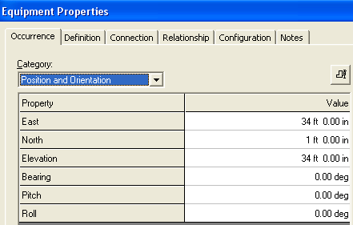
- Select Route Conduit Command
- Select Conduit Port 4 on Electrical Enclosure E-300A as starting location

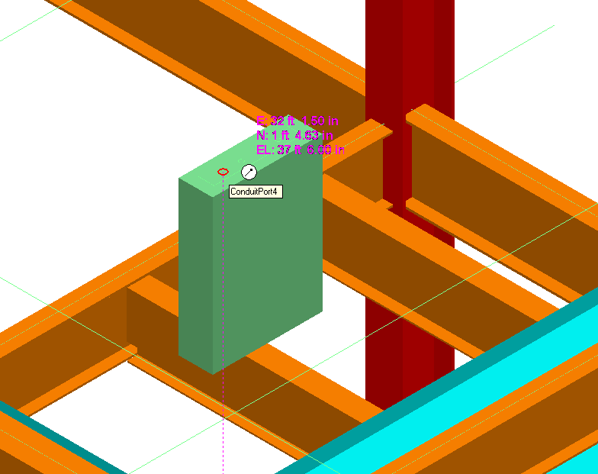

- Set the system toA2, U03, Electrical, Control, conduit
- Set the Spec to Spec0
- Switch to Cable fill category
- Set as shown
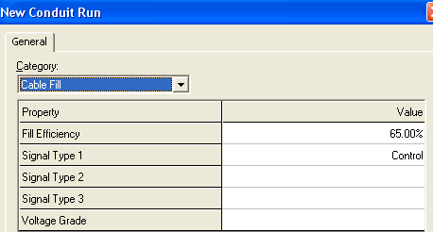
- Route up 3’, Route South 2’, Place a TEE as shown and complete routing as shown
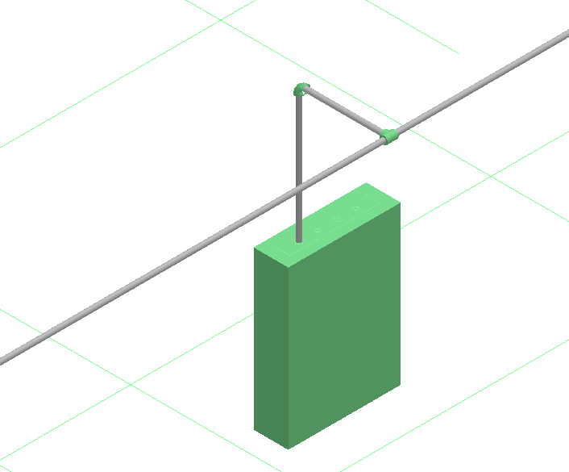

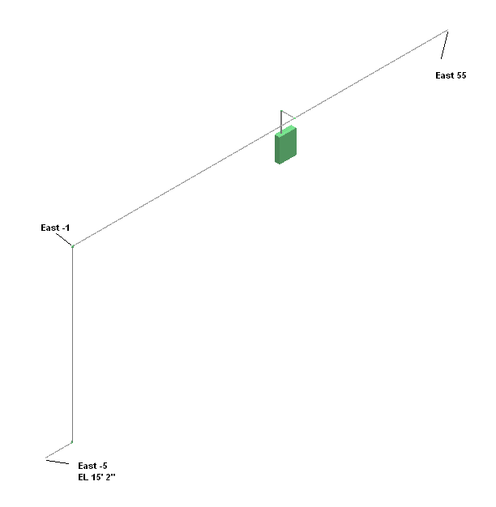

LAB-14: Branching from Elbows using Spc0

- Open a Session file with Imperial Units
- Define Workspace to Display U03 and U03 CS
- Change active CS to U03 CS
- Select set target to origin command
- Set locate filter to cableways
- Hide all cableways except the Low Voltage at elevation 15’ 2” as shown
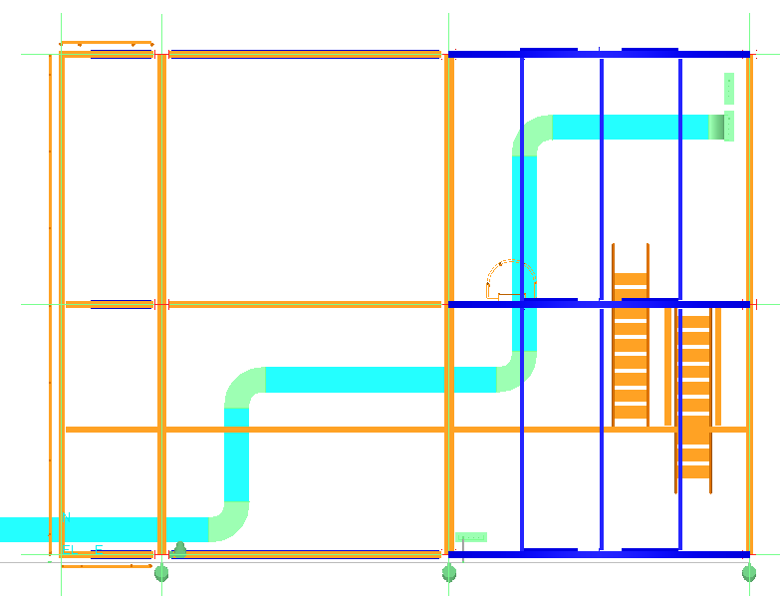
- Select Route Cableway command
- Select mid point of first elbow as starting point as shown below
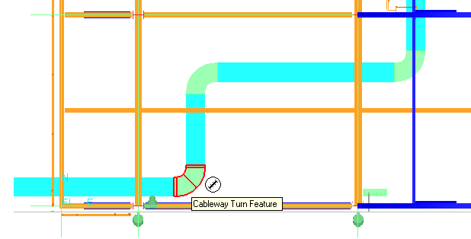
- Make sure system is set to A2, U03, Electrical, Low Voltage, CT
- Change the Spec to Spec0
- OK on the form
- Change the size to 6” X 4”
- Route as shown
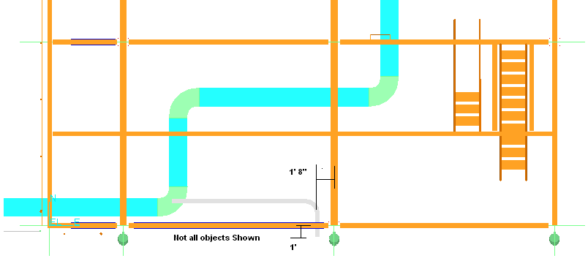

LAB-14A: Miter Turns

- Set the locate filter to cableway features
- Select the Elbow as shown
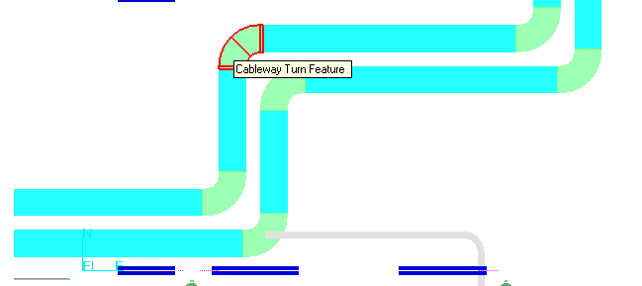
- Under type, change from default to Miter

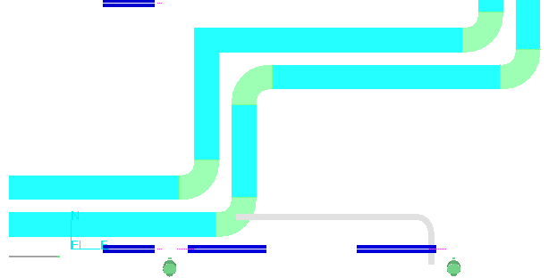

LAB-15: Cableway Splits

- Open a Session file with Imperial Units
- Define Workspace to Display U01 and U01 CS
- Select insert split command
- When prompted for straight features
- Select the bottom SF on the North side as shown
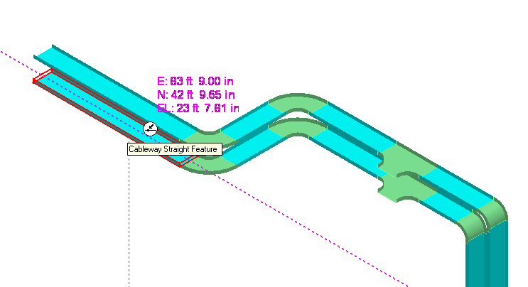
- Set the Split properties as shown
- Finish on the form
- Zoom in and you will be able to see the gap
- Select insert split command
- Select the Top SF
- Set the Split properties as shown
- Finish
- Zoom in and see multiple splits are placed
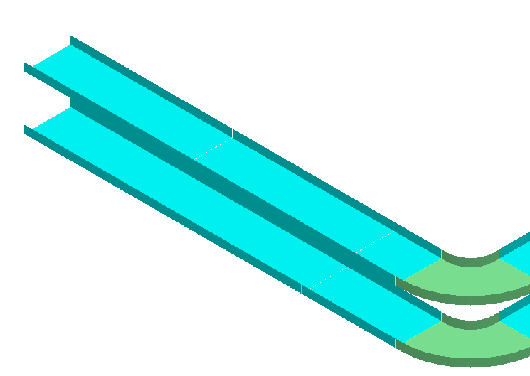

LAB-16: Routing Cable

- Open a Session file with Imperial Units
- Define Workspace to Display U01 and U01 CS
- Select insert cable command
- Select A2, U01, Electrical, Control, Cables for system
- Name the Cable CC-001
- Select Control for Signal Type
- Select the Part Number as shown
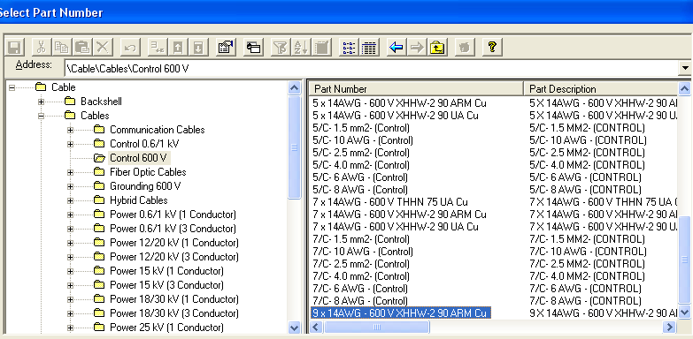

- For originating Device, select A2, U01, Equipment , Electrical Device
- For terminating Device select A2, U01, Equipment , Pump-001
- Hit Apply Button
- Select Insert Next Cable at the top of form
- Keep the same system
- Name the cable CC-002
- Select Control for Signal Type
- Select the same Part Number used above
- For originating Device, select A2, U01, Equipment , Electrical Device
- For terminating Device select A2, U01, Equipment , Pump-002
- Select OK
- You should have 2 cables running between Electrical Device and Pumps as shown

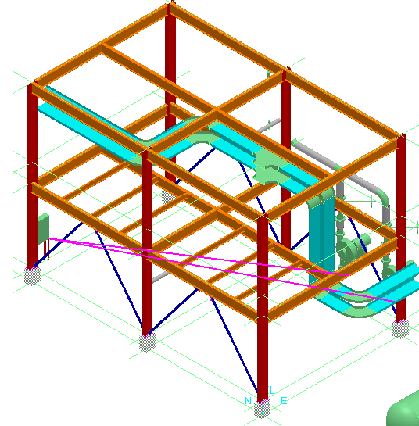
LAB-17: Routing Parallel Cables

- Open a Session file with Imperial Units
- Define Workspace to Display U01 and U01 CS
- Select insert cable command
- Select A2, U01, Electrical, Low Voltage, Cables for system
- Name the Cable LV-001
- Type 2 for parallel cables
- Select Power for Signal Type
- Select the part shown
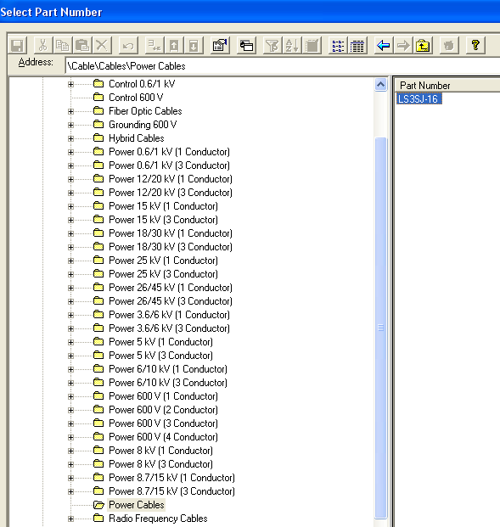
- For originating Device, select A2, U01, Equipment , Electrical Device
- For terminating Device select A2, U01, Equipment , Pump-001
- Hit Apply Button
- Select Insert Next Cable at the top of form
- Keep the same system
- Name the cable LV-002
- Select Power for Signal Type
- Select the same Part Number used above
- For originating Device, select A2, U01, Equipment , Electrical Device
- For terminating Device select A2, U01, Equipment , Pump-002
- Select OK. Notice new parallel cables in Work space explorer
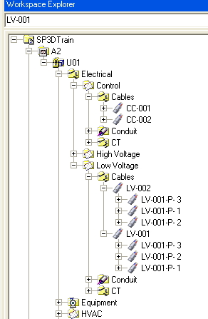
LAB-18: Defining Cable Path (Manual)

- Open a Session file with Imperial Units
- Define Workspace to Display U01 and U01 CS
- Select locate filter to all
- Select cable CC-001 in Work Space explorer
- Go to View, Set view by Cable
- Select Edit Cable Path command
- Software is prompting for cable selection. Green Check on the ribbon bar
- System prompts for position on Cableway for Entry point, Select End feature of Top tray as shown
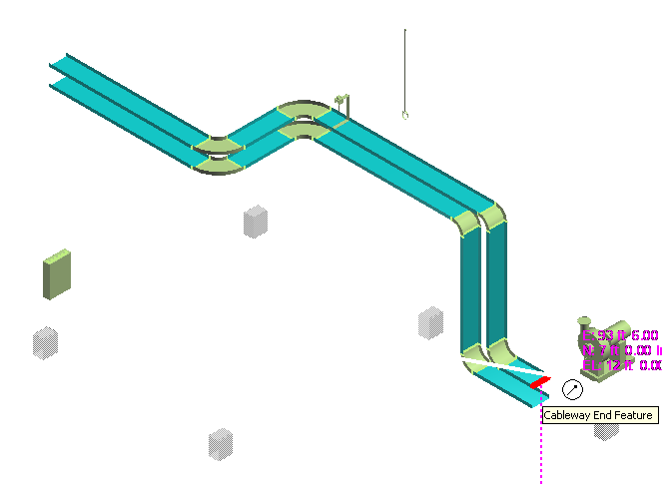
- System shows the cableway path. Make sure cable is going thru the top tray. Green check to accept the path
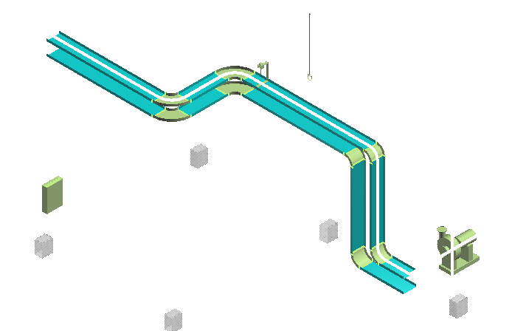
- Select the end feature at the other end of tray as exit point
- Select Finish to complete the cable path
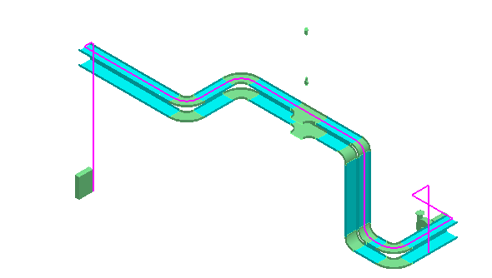
- Select cable CC-001 in WSE and review its properties
- Select View clear clipping, tools > show all

LAB-19: Defining Cable Path (Auto Route)

- Open a Session file with Imperial Units
- Define Workspace to Display U01 and U01 CS
- Set locate filter to all
- In WSE select Cables CC-002, LV-001, LV-002
- Select Edit Cable Path command
- Select Auto Route Option Button
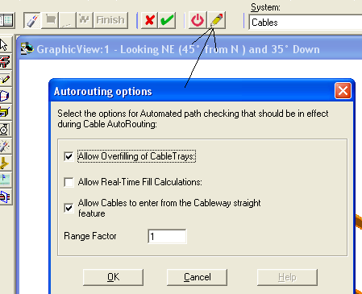
- Set options as shown above and OK on the form
- Select Auto Route option (button before options)
- Software shows the Route for Cables
Note: Software shows control tray for control cables, and Low voltage tray for power cables
- Select Finish
- Review the cable path
- Set the locate filter to Cableways
- Select the Bottom Cableway, open its properties page and switch to cable fill category
- Make sure the Cable fill is set to 60%
- Close the Properties page
- Select locate filter to Cableway Feature
- Select one of the SF from bottom Run
- The ribbon bar show percent fill at 82 percent
Note: If you had a rule set, to change color of cableways when overloaded, this would have changed color
- Switch the locate filter to Cableway
- Select the top Control cableway
- Switch to cable fill category
- Make following changes
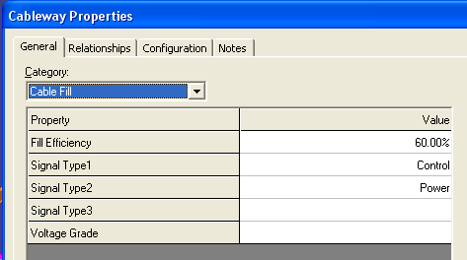
- Ok on the form
- Set locate filter to all
- Select cable LV-002, and delete its path (do not delete the cable)
- Select cable LV-002
- Software opens up the Edit Path ribbon bar
- Select the Set entry point option
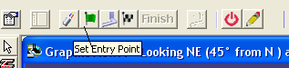
- Select the End feature of top tray as shown
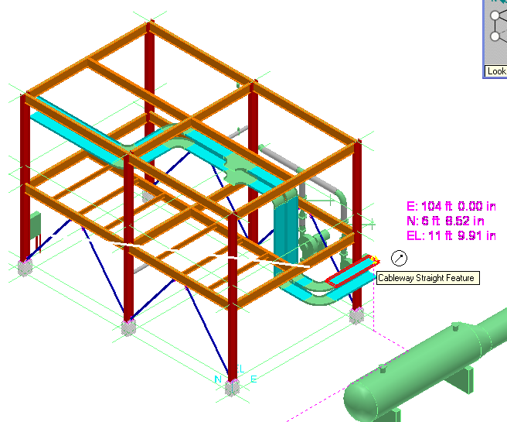
- Select Auto Route button
- System completes the route
- Finish

